**Brooklyn torah gazette**

**For parshas korach 5779**

Volume 3, Issue 44 (Whole Number 140) 3 Tammuz 5779/ July 6, 2019

**Printed L’illuy nishmas Nechama bas R’ Noach, a”h**

For a free subscription, please forward your request to [***keren18@juno.com***](mailto:keren18@juno.com)

**New York City is Considering a Ban on Fur. Hasidic Jews and Jewish Fur Dealers Aren’t Happy.**

**By Joseph Dolsten**



**Marc Kaufman’s family has been in the fur business in New York for five generations. (Josefin Dolsten)**

NEW YORK ([JTA](http://jta.org/)) — It’s summer and Marc Kaufman has thousands of coats in the basement of his store in Midtown Manhattan. For a fee, the fifth-generation fur dealer cleans and stores them for his customers to help prevent heat damage.

Upstairs there are racks and racks of coats for sale — lynx, mink, chinchilla, sable and coyote, Kaufman’s personal favorite. There’s everything from a long white fox coat speckled with bright pink, black and blue to a bluish gray bomber-style chinchilla jacket.

Coats sell for an average of $3,000 but can go for up to $150,000. Kaufman has sold to big names such as [Jennifer Lopez](https://kaufmanfurs.com/designer-furs-mink-coats-fur-coats/jlo-jennifer-lopez-rocks-marc-kaufman-fur/) and [50 Cent,](https://kaufmanfurs.com/designer-furs-mink-coats-fur-coats/50-cents-fur-collection-rocks/) and his grandfather sold fur to Marilyn Monroe and Liberace.

But new legislation proposed in the City Council here could threaten Kaufman’s livelihood, and those of some 150 other stores in New York that earn the majority of their income through fur sales.

In March, City Council Speaker Corey Johnson introduced legislation that would ban the sale of new fur apparel.

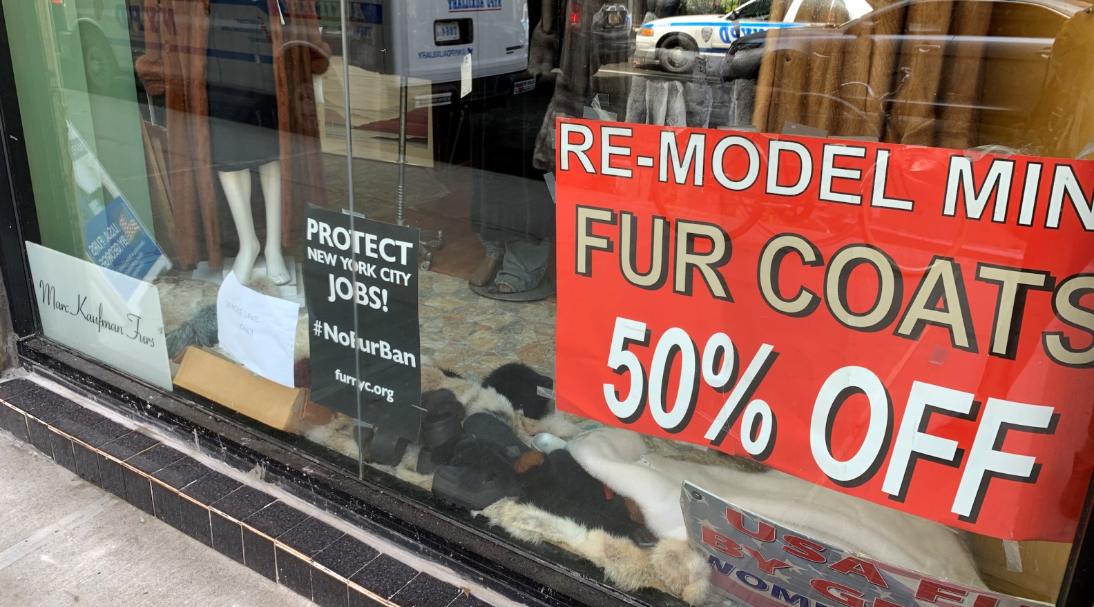

**There are more than 150 fur stores in New York City, according to a trade group advocating against a proposed fur ban. (Josefin Dolsten)**

“As an animal lover, I believe it is cruel to kill an animal just for the purpose of people buying and wearing a fur coat. There is really no need for this,” Johnson said in a statement ahead of introducing the bill.

In May, the council heard testimony from opponents and critics of the ban. Following the hearing, Johnson [slightly changed his tune,](https://newyork.cbslocal.com/2019/05/30/nyc-fur-ban-city-council-speaker-corey-johnson/) saying he would want a potential ban to be phased in over time to have a less dramatic impact on the industry.

The New York State [Senate](https://www.nysenate.gov/legislation/bills/2019/s6272) and [Assembly](https://www.nysenate.gov/legislation/bills/2019/a519) also are considering bills to ban the sale of fur in the state.

Stores that earn the majority of their revenues through the sale of fur employ about 1,110 people, [according to Fur NYC](https://furnyc.org/impact/), which opposes the ban. That doesn’t include a supply chain that includes marketing, banking and insurance, says the trade group.

“A fur ban would be catastrophic to New York City — eliminating a historic manufacturing community, along with thousands of jobs for New Yorkers who’ve never made another living and millions of tax revenue that fund critical government programs that help New Yorkers,” according to Fur NYC.

Like many other stores in New York’s Fur District, there are signs posted on Kaufman’s store protesting the proposal.

“If they don’t want to wear furs, they don’t [have to] wear it,” he told the Jewish Telegraphic Agency last week. “If they don’t want to eat meat, let them not eat meat. But don’t impose your views on me.”

Jews once dominated the New York fur and garment industry. The boom of the ready-to-wear clothing industry after the Civil War coincided with a large influx of Jewish immigrants from Eastern Europe, said Daniel Soyer, a professor of American Jewish history at Fordham University who researches the garment industry. Indeed, Kaufman’s own family entered the industry in 1870 after emigrating from Russia, Germany and Hungary.

Since ready-to-wear clothing production was a new industry, Jews faced fewer barriers than in already established fields, Soyer said. Some Jews also brought relevant skills from their native countries.

The number of Jews working in the garment industry remained high through the 1920s ([in 1910, three-quarters of the furriers in the city were Jews](https://www.myjewishlearning.com/article/jewish-garment-workers/)). It started decreasing in the 1960s with the rise of mass-produced clothing, according to Soyer.

Animal rights activists say the practice and methods of killing animals for their fur is cruel. Starting in 1992, People for the Ethical Treatment of Animals, or PETA, began a memorable “Rather Go Naked Than Wear Fur” campaign that eventually included celebrity spokespeople.

[During a hearing on the proposed legislation last month, Johnson showed graphic images of animals housed and killed for their pelts](https://www.amny.com/news/nyc-fur-ban-1.31129503). A number of celebrities, including fashion guru Tim Gunn, [have spoken out with PETA in favor of the ban](https://www.peta.org/blog/new-york-city-fur-ban-celebrities-peta/).

In addition to fur dealers, a number of groups oppose the proposed ban. They include members of the African-American community, for whom fur continues to be a status symbol, and some environmental activists, who argue that it will lead to an increase in non-biodegradable fake fur coats.

Also opposing the ban are Hasidic Jews, who often wear the cake-shaped sable hats known as shtreimels on Shabbat and holidays. Made from the tails of sables and foxes, the hats can cost as much as $5,000.

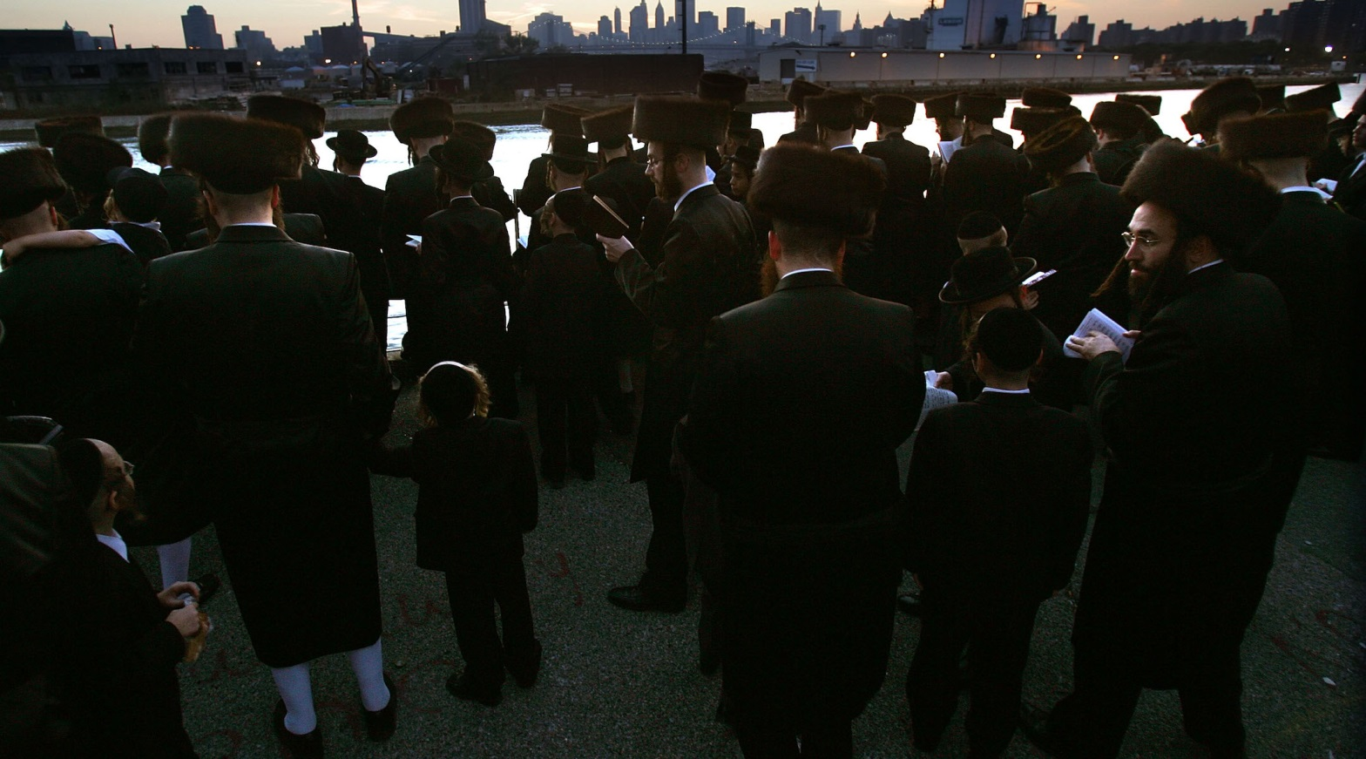

**Hasidic men, seen here during a Rosh Hashanah ceremony in Brooklyn, have a tradition of wearing fur-lined hats on Shabbat and holidays. (Mario Tama/Getty Images)**

Councilman Chaim Deutsch of Brooklyn cited the Hasidic custom as a reason why he opposes the ban. The legislation contains a religious exemption that would allow the sale of fur to those using it as part of their faith.

“If we ban fur and then you have people that are still out there wearing it, considering the fact that hate crime in New York City is on the rise, people will be targeted on the streets, saying, ‘Why are you wearing this if there’s a fur ban?’” Deutsch, an Orthodox Jew, [told The New York Times.](https://www.nytimes.com/2019/05/15/nyregion/fur-ban-nyc-sales.html)

Alexander Rapaport, a Hasid who runs [a Brooklyn-based network of kosher soup kitchens](https://www.masbia.org/), echoed Deutsch’s fears.

“There are thousands and thousands of citizens who wear [the shtreimel] for culture and tradition, and it’s almost symbolic to their way of life,” he told JTA.

Rapaport questioned the efficacy of the bill, since it would only ban fur in New York, and wondered whether it would put “a bulls-eye on every shtreimel.”

Some see the religious exemption as problematic and untenable. Bezalel Stern, an attorney at Kelley, Drye & Warren, LLP, representing the International Fur Federation, says the exemption violates the First Amendment’s Establishment Clause because it would favor religion and have the government evaluate the validity of a person’s religious claim.

Stern fears that if the law were to pass, the religious exemption would not stand up in court.

“I think the [City Council] speaker knows that the religious exemption is unconstitutional and he’s putting it in because he wants to — excuse my pun — pull the fur over people’s eyes in order to get it passed,” Stern said.

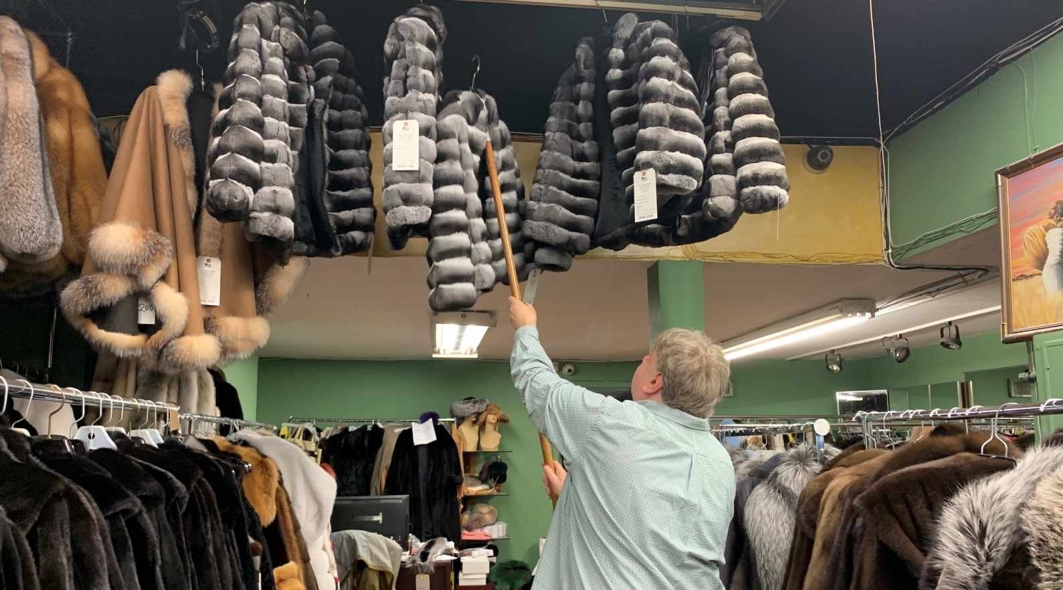

**Marc Kaufman sells fur to a number of high-profile celebrities at his Manhattan store but says most customers are regular people. (Josefin Dolsten)**

But the ban has Jewish proponents, too.

Rabbi Shmuly Yanklowitz, the founder of [Shamayim: Jewish Animal Advocacy](http://www.shamayimvaretz.org/), criticized Hasidic opposition to the ban in an email to JTA, saying that wearing shtreimels is a custom but not mandated by Jewish law.

“It is not required to actualize holiness,” said Yanklowitz, who is Orthodox. “What is required, however, is the need to follow the notion of ‘tzar ba’alei chaim’: not causing needless pain to animals.”

Jewish Veg, which advocates for veganism in the Jewish community, also threw its support behind the bill. [In a statement, the group said that fur industry practices constitute “egregious violations of Jewish ethics.”](https://www.jewishveg.org/Fur-Free-NYC)

“Judaism mandates that we treat animals with exquisite and sensitive compassion, and the practices of the fur industry grotesquely violate this mandate,” the organization said.

Meanwhile, Kaufman says he’s more focused on running his business than worrying about the legislation, which he believes is unlikely to pass.

“G-d will take care of everything,” he said. “Furs come from G-d, it’s part of the Bible.”

*Reprinted from the June 21, 2019 dispatch of the JTA (Jewish Telegraphic Agency.)*

**Rav Avigdor Miller**

**On Looking at Girls**



**QUESTION:** What's so bad about looking at girls?

**ANSWER:** Why look at girls?! It's a waste of your time to look at girls. You want to look? Look at the seeds on the trees. Look at the maple seeds on the ground. Now, that's something to look at! Girls are nothing. There's nothing to see in girls. It's only your imagination.

And the way to get rid of your imagination, is to marry the girl. Marry the girl, and you won't look at her in that way anymore. And that proves that it's all imagination. It's nothing at all. It's just a דמיון - an imagination running wild. Rav Yisroel Salanter said that imagination is our greatest enemy. It makes us think of nothing like it's something. But it's nothing at all.

And not only girls are nothing; boys are also nothing at all. Nobody is anything at all. Unless you recognize that they are a Jew, a צלם אלקים. That's something else altogether. Every Jew is an image of Hashem.

Oh yes, that is very important. That's how you should be looking at a Jew. But that's not how you're looking at the girls. And it'll take you a long time to get there, when you'll be able to look at a fellow Jew and see the צלם אלקים . So in the meantime, let your eyes look into the Chumash, into the Mishna, into the Gemara. That's where your eyes should be.

*Reprinted from the june 21, 2019 email of Toras Avigdor (Tape #E-121).*

**The Shmuz onParshas Korach**

**Questions Have Answers – Answers Don’t Have Answers**

**By Rabbi Bentzion Shafier**

**Founder of TheShmuz.com**



“*Korach the son Yizhar, son of Kahas, son of Levi, separated himself with Dathan and Aviram, the sons of Eliav, and On of Peleth, the offspring of Reuvain*.” — Bamidbar 16:1

**Korach’s rebellion**

The parshah opens up with Korach gathering together 250 men of stature and mounting a rebellion against Moshe and HASHEM.

Rashi explains that Korach’s motivation was jealousy; he felt that he should have been appointed to the position of Nasi of his shevet, and was seeking revenge. Even though Moshe Rabbeinu was commanded by HASHEM to appoint Elizaphan Ben Uziel to that position, Korach felt that Moshe made this decision on his own, and he set out to depose him. He would prove that Moshe was saying things in the name of HASHEM that HASHEM never told him to say.

To prove his point, Korach gathered 250 leaders of the Jewish people and gave each one a tallis made completely out of techeiles. (A tallis requires only one strand of the tzitzis to be dyed the purple/blue color of techeiles.)

Korach brought this group in front of Moshe and asked, “If someone has as a garment made completely of techeiles, is he obligated to put tzitzis on it?”

Moshe answered, “He is obligated.”

“Does that make sense?” Korach demanded. “A garment that is made completely of wool requires only one strand of techeiles, and yet you say that a garment made completely of techeiles needs additional techeiles. It is impossible!”

The entire group began laughing at Moshe, and with this Korach launched his revolt.

**Korach’s question wasn’t that powerful**

It seems clear from the Medrash that Korach’s strategy was to ask a question so powerful that Moshe wouldn’t be able to answer it. This would prove that what he said couldn’t be from HASHEM. The difficulty with this Rashi is: what is so potent about the question that Korach asked? It might well be that a garment made of plain wool requires tzitzis with one strand of techeiles, and that a garment made completely of techeiles still requires tzitzis with a strand of techeiles in it. The question doesn’t seem particularly plaguing.

Furthermore, if Korach wanted to ask questions, there are far more difficult questions that he could have asked. The Medrash tells us that Shlomo Ha’Melech couldn’t understand the system of the parah adumah. The purpose of the parah adumah is to purify the person sprinkled with its ashes. Why should the Kohain who sprinkles the ashes become impure by doing it? If it is an act that purifies, how can it make the one doing the act impure?

This is an enigma. Surely if Korach were looking to find an unanswerable question to disprove Moshe, he could have asked this or many other difficult questions. What was so unanswerable about the techeiles question that it caused 250 Torah scholars to laugh at Moshe’s answer?

The answer is based on understanding how bias blinds the mind of man.

**Questions have answers; answers have no answers**

Rav Chaim Volozhin was once approached by a student who had left the yeshiva. This was at a time when the Enlightenment was in full swing, and many young, impressionable yeshiva students were struck by the lure of modern studies’ promise to fulfill all of mankind’s needs. The Torah’s ways were seen as archaic and outdated; science alone could provide the answers to all that ailed the world.

This student, after having been outside the yeshiva for a while, wanted to return. “I want to come back,” he told Rav Chaim, “but I have many questions.”

Rav Chaim asked him, “Did these questions come to you when you were in yeshiva or after you left?”

The boy innocently asked, “What difference does it make? These are questions that I have.”

Rav Chaim responded, “If these questions troubled you before you left yeshiva, they are questions, and for questions I have answers. However, if these questions only began troubling after you left yeshiva, then they aren’t questions; they are answers. For answers, I have no answers.”

**Bias blinds a man**

Rav Chaim was explaining a basic principle in man: that bias greatly affects our ability to understand. If a person has a prejudice against a way of thinking, then he isn’t open-minded and he becomes incapable of hearing the truth, no matter how clear and no matter how obvious – he just isn’t listening. To allow for free will, HASHEM gave man this uncanny ability to shut his mind down, to ignore all proofs and all logic and to blindly follow his desires. When a man has made up his mind and doesn’t want to hear the truth, there is nothing that can prove him wrong. His mind is shut.

This seems to be the answer to understanding Korach’s question. Korach wasn’t approaching Moshe to seek the truth; his sole intention was to mock and discredit Moshe. With that mindset, the strength of the question and whether there was an answer to it didn’t matter. There was no question, only scorn and derision in the guise of a question. It was a question that had no answer because it wasn’t a question – it was an answer.

This concept has great relevance in our lives. There will be times when we are perplexed by situations that we don’t understand. We don’t know which way to turn, and the answers that we seek aren’t forthcoming. It may well be that we can’t find the answer, but sometimes when the answer eludes us, it’s not because the answer isn’t there, but because we aren’t listening. Sometimes the answer may be right there, but we aren’t open to it, and so we can’t hear it. It’s not that there aren’t answers; it is that we aren’t asking questions.

HASHEM created man with a heart of truth, and if a person puts aside his bias and opens his mind, he is capable of hearing the answer. The key to the process is to ask himself one pointed question: what is the truth? Forget my self-interest; forget the consequences; what is the right path? What does HASHEM want me to do? If a person follows this process, his inner sense will guide him past the darkness and he will be able to find the truth.

*Reprinted from this week’s website on TheShmuz.com This is an excerpt from the [Shmuz on the Parsha book](https://theshmuz.com/product/shmuz-on-the-parsha-book/).*

**The Connection of Two**

**Paragraphs in the Mezuzah and**

**G-d’s Blessings and Protection**

**From the Talks of the Lubavitcher Rebbe**

**Rabbi Menachem Mendel Schneerson, Zt”l**

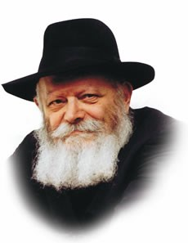

In this week's Torah portion, Korach, Korach and his band of rebels sought to undermine Moses' authority. According to the Midrash, one of the taunts with which they challenged him was the following question, which they assumed was merely rhetorical: "Is a house full of Torah scrolls exempt from the requirement of affixing a mezuza to the door post?"

A house full of Torah scrolls would obviously contain many repetitions of the required chapters--the "Shema" and the "And it will be, if you will obey My commandments"--that are written on a mezuza. Much to his surprise, however, Korach was informed by Moses that even this house would need a mezuza.

"How can two small paragraphs on a mezuza be more important than the entire Torah?" Korach sneered. Korach fully expected Moses to answer that a house full of Torahs is exempt. His complaint against Moses was that every Jew is a "Torah"--as inherently holy as a house full of scrolls. Why then, do we need a "mezuza"--the office of the priesthood, with the extra authority it affords Aaron, the high priest, and his sons?

Although Korach's argument, that every Jew is holy, is certainly correct, G-d also wanted priests, symbolized by the mezuza, who would serve Him in the Holy Temple. The mezuza is attached to the door post at the entrance of the home and faces outward, into the street. Its holiness radiates and protects the dwelling's inhabitants, not only when they are at home, but also, when they go outside.

The holiness of a house full of Torah scrolls which does not have a mezuza is liable to remain inside, removed from the mundane details of daily life. When a Jew, however, affixes a mezuza to his door, he makes a public statement that his is a Jewish home, subservient to "the L-rd is our G-d, the L-rd is One." Its inhabitants recognize that G-d's Torah and mitzvot apply equally in the home and in the street.

This is also symbolic of the role of the priests. Their task is to help the inherent holiness of every Jew reveal itself and have lasting influence in the physical world. The priests, through their service in the Temple, assist the entire Jewish nation in its task of transforming the world into a dwelling place for G-d.

Korach insisted that the measure of holiness within every Jew was sufficient, but Moses corrected him. The holiness within must be carried outside, into the street, as well.

This principle may also be applied to our daily lives. It is not enough for a Jew to feel a special connection to G-d at certain times--during prayers, while learning Torah or on Shabbat. The Jew must nurture that special relationship with G-d until he is aware of it every minute of the day, even when occupied with more mundane tasks. We must therefore affix a mezuza in the spiritual sense as well, setting before ourselves the constant knowledge that "the L-rd is our G-d, the L-rd is One," which will bring down G-d's blessing and constant protection.

*Reprinted from the Parashat Korach 5753/1993 edition of L’Chaim Weekly (Issue #263), a publication of the Lubavitch Youth Organization in Brooklyn, NY.*

**Rabbi Berel Wein on**

**Parashat Korach**

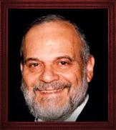

The tragedies and difficulties that befell the Jewish people in the desert of Sinai continue to multiply in the Torah reading of this week. This week's sad story involves unique personalities affected by human ambition, jealousy and a complete misreading of one's true role in the family and society.

Korach sees himself as being a far greater person than he really is. He is convinced that he is truly a rival to Moshe and Aaron and is entitled to the same degree of leadership that they enjoy. He is not at all satisfied in being the head of one of the families of the Levites and performing the service in the Tabernacle and Temple.

Such false leaders always surround themselves with other malcontents who are also interested in destabilizing the leadership of the people for their own personal, psychological and, many times, financial advantage.

In every society there are those who are dissatisfied with their lot in life. Their frustration translates itself into episodes of anger and the vilification of others, especially of the leadership then present in that society. Revolutions are always popular and those who lead them continually promise a new and better society, a utopia that unfortunately is never realized and usually turns into tyranny and the oppression of others.

Jealousy and disaffection are always with us no matter who our leaders may be and what type of society or social norm currently prevails. This frustration and dangerous arrogance always spawns further frustration as the problem that is to be addressed is a personal one. There are no outside forces or governmental action that can truly solve this inner angst. Truly, we are our own worst enemies.

The punishment visited upon Korach and his followers is their complete elimination from society generally. It is as though the Torah is aware that there is no society or leadership that can really satisfy people who are professional malcontents. It is not only individuals that are swallowed up and extinguished, but throughout history it is recorded that ideas, movements, political parties and immoral social norms are also subject to extinction.

This doesn’t mean that these groupings will never again appear in society. They always do, but they do so in differing forms and morph into changing mores. The Torah itself tells us that even though the original Korach may have been buried and disappeared, the descendants of Korach have not disappeared. Rather, they rise in every generation in different forms, victims of their own inner frustrations, jealous of the accomplishments of others and determined to turn over the entire applecart in order to achieve their own aims.

Human history – and Jewish history is no exception to this phenomenon – is littered with the debris of failed personal ambitions and unnecessary disputes and social divisions. We are bidden to learn and benefit from the mistakes and follies of others. The Torah reading this week certainly has many important lessons to teach us about life, society and human behavior.

*Reprinted from this week’s website of Rabbiwein.com*

**Chillul Hashem Alert**

**By Rabbi Moshe Meir Weiss**

As summer approaches there is an annual migration to our favorite vacation spots.  In the tristate area, over a half million people make the annual pilgrimage to the Catskills summer homes and bungalow colonies strewn all over Ulster and Sullivan counties.

Towns such as Monticello, Woodbourne, Fallsburg, Ellenville, Kiamesha, Swan Lake, Hurleyville and many others are packed with myriads of Orthodox Jews.  All these city-folk come like an avalanche upon these quiet rural towns suddenly descending at the end of June like a raging bull in a china closet.

This is a good time for us to brush up on the severity of *chillul Hashem*, the crime of desecrating Hashem’s Name in front of the other nations.  (It applies in front of other Jews as well.)  The Gemora teaches us that this transgression is so heinous that when it is perpetrated, even repentance, suffering, and the holy day of Yom Kippur combined do not fully atone.  Only death completely atones for this terrible crime.



**Rabbi Moshe Meir Weiss**

In wanting to convey how horrible chillul Hashem is, the Alenu L’shabei’ach relates the following anecdote. There was once a couple in Eretz Yisroel who suffered from terrible marital discord.  The husband, wanting to wreak hurt to his wife, put in motion to send their Jewish son to a monastery in Italy.

Horrified, friends of the family wanted to go to the government to stop this at all costs. There was however a concern that the major news outlets would get a hold of the story and it would result in a chillul Hashem.  However, those that were involved in the case felt that the risk was justified in order to save the child from *shmad*, from being sent to a catholic mission.

They consulted Rav Shlomo Zalman Auerbach, zt”l, zy”a, the *Posek Hador*, and to their surprise he told them that if there was a chance of chillul Hashem, they cannot risk it, even to prevent the loss of a Yiddisher *neshama*.  This is a striking example of how serious the crime of desecrating the Name of Hashem is.

I know a family that was attacked in the secular papers regarding a nasty custody battle. When the papers asked them if they wanted to comment to defend themselves, Rav Dovid Feinstein, shlit”a, ruled that they could not participate in the discussion in the secular press even to defend themselves for it would be advancing more chillul Hashem.

That’s asking a lot from a person – not to defend themselves against public humiliation – but that’s how high the stakes are when it comes to chillul Hashem.  So let’s start talking about how this subject applies to the many city-folk who ‘invade’ the peaceful mountains during the summer.

The first thing that needs to be eliminated is horn honking from our cars.  The bedtime for many rural-folk is ‘early to bed and early to rise,’ while many of us city-people start first waking up when they are already in bed.  We have to be aware of this whether it comes to blowing the horn, slamming the car doors, or just carrying on in a boisterous summer-way when many of the locals are already sleeping.

Then there’s our behavior in the supermarkets.  If you’ve ever been to the Catskills in the winter, you’ll see how nicely the shelves are setup and how orderly the store looks.  So, while shopping if you decide not to take an item, put it back in its place – especially if it needs refrigeration. Try to bring your cart back to the store or to the place where they are gathered, and not leave helter-skelter in the parking lot.

And here’s something to really think about.  Don’t go around tasting the grapes, having your kids taste them, and popping the olives in your mouth, and even munching on the grapes while they’re already in your wagon.  I sincerely believe that if there’s no sign up saying “*sampling allowed*,” it is theft to taste fruit in order to decide if you want to buy the item.

And, even if some stores will let you get away with this and not escort you out, this is certainly not the behavior of the *Am Segula*, the nation that is supposed to be the model of behavior.

If I see a gentile waiting in line who has only two items, I always try to let them go ahead of me so they don’t mutter under their breath, the ‘Jewish invasion.’ Right or wrong, we need to be sensitive when we are trampling on their peace and quiet.  And yes, it is true that they are looking for things to blame us for. That just means that we must be doubly careful not to give anyone ammunition.

When driving in the night, we must always shut off our bright headlights to oncoming traffic and we shouldn’t drive like it’s a video game. Let’s remember that the locals are very proud of their pristine unpolluted environment so don’t open the car window and toss out the leftover drink, a bag with a dirty diaper or the wrapper from a nosh, carelessly to the side of the road. There are many more examples but the main thing is to heighten your sense of awareness and to be truly inhibited to causing any type of chillul Hashem.

Finally, I’m sorry there’s a need to mention this but it should be obvious to ensure before having your children with other children that they are properly vaccinated. In Yiddishkeit, we follow the majority, especially in the face of *sakana*, danger, and chillul Hashem. The overwhelming majority, 90 percent plus of master physicians and *Godolei Yisroel* hold that it is mandatory to vaccinate.  Any other discussion is a waste of time.

The massive chillul Hashem that has resulted already on a global stage from measles epidemics needs to be repaired.  Furthermore, as a child that had rubella, measles and mumps, I can tell you that only a criminally negligent parent will abstain from vaccinating a child.

One more point. A smile goes a long way in improving relationships. When you pass a gentile in the parking lot or in Home Depot tilt your head in greeting or give a smile. If thousands of us take this not so little step, we will make a huge difference in their attitude towards us

May Hashem bless us with the smarts to avoid chillul Hashem and in that merit may we be blessed with long life, good health, and everything wonderful.

*Reprinted from the June 26, 2019 website of Matzav.com*

**The First Rebbe of Bobov – Part Three**

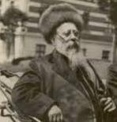

**Rabbi Benzion Halberstam, hy”d, son of**

**R. Shlomo and second Rebbe of Bobov.**

In 1892, R’ Shlomo was appointed Rav of Bobov. During his twelve years in Bobov, R’ Shlomo’s circle of chassidim steadily grew. The chassidim who streamed in to bask in his presence were not only elderly or mature Torah scholars. R’ Shlomo attracted the young students who looked to him as their guide and mentor.

R’ Shlomo suffered from a weak heart. As his cardiac illness worsened, he transferred the administration of the yeshivah to his son, R’ Ben Zion hy”d (his eventual successor). Despite his illness, however, R’ Shlomo never detracted from his full daily schedule of Torah study and worship of Hashem. He would continue to “rise like a lion” each morning, and pray with deep devotion.

R’ Dovid Gutman had become a loyal chassid of R’ Shlomo. His wife had recovered from a deathly illness due to the power of R’ Shlomo’s blessing and prayers. R’ Dovid and his wife were childless after many years of marriage, and he therefore asked R’ Shlomo to bless them with living offspring.

R’ Shlomo told him, “This would not be for your benefit… you would need great Heavenly mercy… Do not press me on this matter…” But R’ Dovid would not give up so easily, and he pleaded with R’ Shlomo until the latter blessed him that they would have a son.

**A Year Later the Blessing was Fulfilled**

A year later, the blessing was fulfilled. Yet when the child turned three, R’ Dovid fell critically ill. When he felt that his days were numbered, he told his family, “R’ Shlomo tried to convince me not to seek his blessing for children, as he knew that it would mean forfeiting my longevity.” With those words, he returned his soul to His Maker.

When the financial situation of the Bobover Yeshivah became desperate, R’ Shlomo was forced to travel to the nearby villages to raise funds. Wherever he went, R’ Shlomo was greeted with honor and warmth. People flocked to see the holy Rebbe, to seek his blessings and advice, and all gave generously to his cause. When the successful mission had raised approximately 12,000 zlotys, it was time to return home.

On the way back to Bobov, R’ Shlomo and his entourage stopped at a small village to rest. Here, too, word spread that the Rebbe was in town and people streamed to R’ Shlomo. One man who approached was not only not a Bobover chassid, but was an antagonist of R’ Shlomo’s who had in the past caused the Rebbe much anguish.

**The Former Antagonist Humbles Himself Before the Rebbe**

Now he came humbly before the Rebbe relating his tale of woe: he had gone bankrupt and was drowning in a sea of debts. If he would not pay his creditors soon, he would be forced to flee the country like a common criminal. Bursting into tears, he begged the Rebbe to help him.

Without hesitation, the Rebbe handed over the entire sum of money which he had so painstakingly collected. After the petitioner left, R’ Shlomo called in his gabbai and informed him that, as they did not have enough for the fare home, he should collect some money.

Puzzled, the gabbai asked, “But did we not just collect a large sum? Surely there is enough…”

When R’ Shlomo told him where that sum of money had gone, he was aghast. How could the Rebbe have given away all the money, when it was so urgently needed – and to such a man, who had been one of his most vociferous opponents!

When R’ Shlomo saw how upset the gabbai was, he told him, “Had I given the money to one of our prominent chassidim, doubtless you would have approved! You are distressed because I gave the money to someone you perceive as my enemy. It is precisely for this reason that I wished to help him – I wanted to conquer my yetzer hara (evil inclination)! I was presented with a challenge: would I transgress the commandment of “lo si’kom” (do not take revenge)? Surely you should be happy that I passed the test, not upset!

**Bothered by Only One Question**

There was only one question I had. As you know, I am heavily in debt, and because of that I was not certain if I should give this man the money I had collected, as this would mean deferring repayment of my debts until I can travel again to raise funds. I concluded that I should give him the money, based on the mitzvos of loading and unloading someone’s animal.

The Gemarah (Bava Metzia 32b) discusses these commandments, and tells us that if presented with both opportunities simultaneously, loading one donkey and unloading another one, generally the mitzvah of unloading takes precedence. This is because the latter relieves an animal of pain, and as we are also enjoined against “tzaar baalei chayim,” we rescue the animal as soon as possible.

However, if the donkey requiring loading belongs to your enemy, and the one needing unloading belongs to a friend, the enemy’s donkey has priority. And why is that? יצרו את לכוף כדי – it would be more important to subdue his evil inclination. It is a great thing when a person succeeds in overcoming his natural bent! I had a similar dilemma here: I had a choice of either repaying my creditors first and then raising money for this unfortunate individual, or helping him first and then collecting the money I need for my debts. In accordance with the Gemarah, I chose the latter.”

**The Gabbai Found Himself Speechless**

The gabbai found himself speechless, overwhelmed by the Rebbe’s actions. R’ Shabsai Kreschover was a follower of R’ Shlomo. In his youth, R’ Shabsai had been a chassid of R’ Yechezkel of Kuzmir, and after his passing, of R’ Chaim of Sanz. When he was elderly, R’ Shabsai once went with his wife to R’ Shlomo for a blessing.

While they were talking, the old woman told the Rebbe that both she and her husband agree that she deserves half of his reward in the World to Come. If she had not permitted him to do so, she argued, he could not have spent weeks and months in the courts of tzaddikim. “I would like you to guarantee my share of my husband’s reward,” she requested.

R’ Shlomo turned to R’ Shabsai and said, “I do not understand you, R’ Shabsai. While you and your wife were discussing your giving away part of your reward, why didn’t you request at least a small share of your wife’s great reward? Think of all the time you spent away from home, while your wife cared for the house and children all by herself.

“Can you imagine the hardships she endured – feeding the family, sewing, laundering clothes, bringing up the children? It was only her great faith in tzaddikim that enabled her to endure the hard work and not complain while her husband sat serenely basking in the warmth of the tzaddikim! You cannot imagine the magnitude of her reward in the World to Come! She does not need a share of yours at all!”

**The Young Man and the Frail Elderly Man**

A young man in Bobov lived with a frail, elderly man. He took care of him constantly, only leaving him alone to go to shul. On Yom Tov, when the prayers were much lengthier, he would remain with the old man and pray at home, going to shul only for Barchu and Kedusha, which must be said with a minyan. On Rosh Hashanah, he would go to shul just to hear the first set of tekios of the shofar; he would blow the remaining tekios himself later in the day.

Once in shul, however, he strongly wished to remain for the Mussaf service and the accompanying tekios. The congregation was surprised to find that R’ Shlomo, who led the Mussaf prayers, ended after only ninety minutes, instead of the usual three hours. When he was asked for an explanation, he told them, “Among the mispallelim in shul, I noticed the chassid who takes care of that old man with tremendous self-sacrifice. I understood that it would mean a great deal to him to remain in shul for Mussaf, and so I did not have the heart to urge him to return to his patient. However, I also did not wish the elderly man to be left alone for a long time, and therefore I rushed the prayers and ended earlier.”

**The Question About Cutting His Fingernails**

When his mother passed away, R’ Shlomo found himself with a halachic problem. His mother had raised her children to be very meticulous in cutting their fingernails very often. In the first week, a mourner is not permitted to cut his nails, but, as his fingernails were just then due to be cut, he thought that perhaps they would be considered an interference when he washed for netilas yadayim before eating bread, and he would be permitted to cut them just a bit. A

As he pondered the dilemma, trying to decide which matter should take precedence, R’ Shlomo fell asleep. His mother appeared to him in a dream and said, “The laws of mourning are not just in order for a person to remind himself that he is in mourning; the fact that the person is keeping all those laws serves as a tikkun (rectification) for the soul of the deceased. By observing these laws you are assisting in the elevation of my soul.” R’ Shlomo awoke, his question resolved.

His final years were filled with physical pain and suffering. He was only 58 years old when his holy soul was summoned to Heaven. R’ Shlomo was staying at a health resort in Germany when he took a turn for the worse and passed away. They brought R’ Shlomo back to Bobov for burial. The mournful cries of R’ Shlomo’s chassidim rent the very Heavens.

He was succeeded by his son, R’ Ben Zion, and with the foundation that R’ Shlomo had built, Bobov chassidus flourished and grew. The yahrzeit of R’ Shlomo ben R’ Meir Nosson Halberstam zt”l, is on 1 Tammuz (1905). May his merit protect us. (Marbitzei Torah MeOlam HaChassidus Vol. 2, Gut Voch, Mazeldige Voch, Glimpses of Greatness)

*Reprinted from the Parshas Shelach 5779 email of The Weekly Vort.*

**Thoughts that Count**

Who is strong? He who subdues his inclination (Ethics 4:1)

Rabbi Nachman of Breslov used to say: The Good Inclination is the same in every individual, but the Evil Inclination is different in everyone, according to a person's stature. The greater he is the stronger will be his desire to sin.

This Mishna may also be applied to the Good Inclination, explained Rabbi Berenyu Leviyer. One must take care to avoid flaunting one's Good Inclination to others, or taking pride in how pious he is!

Rabbi Shimon said there are three crowns: the crown of Torah, the crown of the priesthood, and the crown of kingship. But the crown of a good name surpasses them all (Ethics 4:13)

Why does Rabbi Shimon say there are three crowns, and then enumerate four?

A crown is a mark of recognition which someone earns due to certain accomplishments. When one wears a crown, he receives honor and respect from other people. However, one may be a scholar or active in communal life, but if his behavior is lacking he will have a bad reputation.

In reality, Rabbi Shimon says, there are only three crowns, but we must remember that a crown beautifies a person only if, on top of it, he also enjoys a good name.

*(Lubavitcher Rebbe, zt”l) Reprinted from the Parashat Shelach 5753/1993 edition of L’Chaim Weekly (Issue #263),*